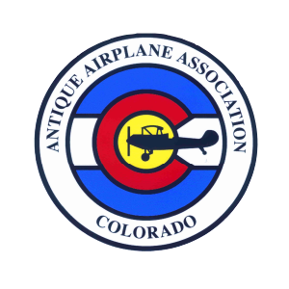
Application for Membership
ANTIQUE AIRPLANE ASSOCIATION OF COLORADO
P.O. Box 234, Longmont, CO 80502-0234

Date: _____________________ New: ___________ Renewal: __________

Membership Class: Adult, plus one __________ Student, college __________

Name(s): ______________________________________________________________________________

Address: _______________________________________________________________________________

City: _____________________________________ State: ______________________ Zip: ____________

Telephone: _______________________ Cell: ____________________ Work: ___________________

Email Address: ________________________________________________________________________

Occupation(s) _________________________________________________________________________

National AAA Membership #: ________________________________________________________

FAA License/Ratings: ________________________________________________________________

Aircraft Owned: Year ____________ Make _________________ Model____________________

N# _____________ Engine ______________________ Flying Status ______________________

AAACO educational activities, outreach, teach/train/STEM, scholarships, and flying events are expensive. Additional donations to any fund are welcome. Under Internal Revenue Service guidelines, you may be entitled to deduct the full value of your donation. EIN# 75-3117749.

Adult (plus one), $35: ________________________________

College Student (with valid I.D) $20: ________________________________

Donations- General: ________________________________

Donations- Scholarship: ________________________________

TOTAL: ________________________________

_______ I wish to join and participate in club functions and agree to pay the annual due.

Signature _____________________________________________ Date ___________________________

Check/Cash Attached ___________ Other Payment Method (Please Specify): _________________

Please make checks payable to AAACO. Thank You!

